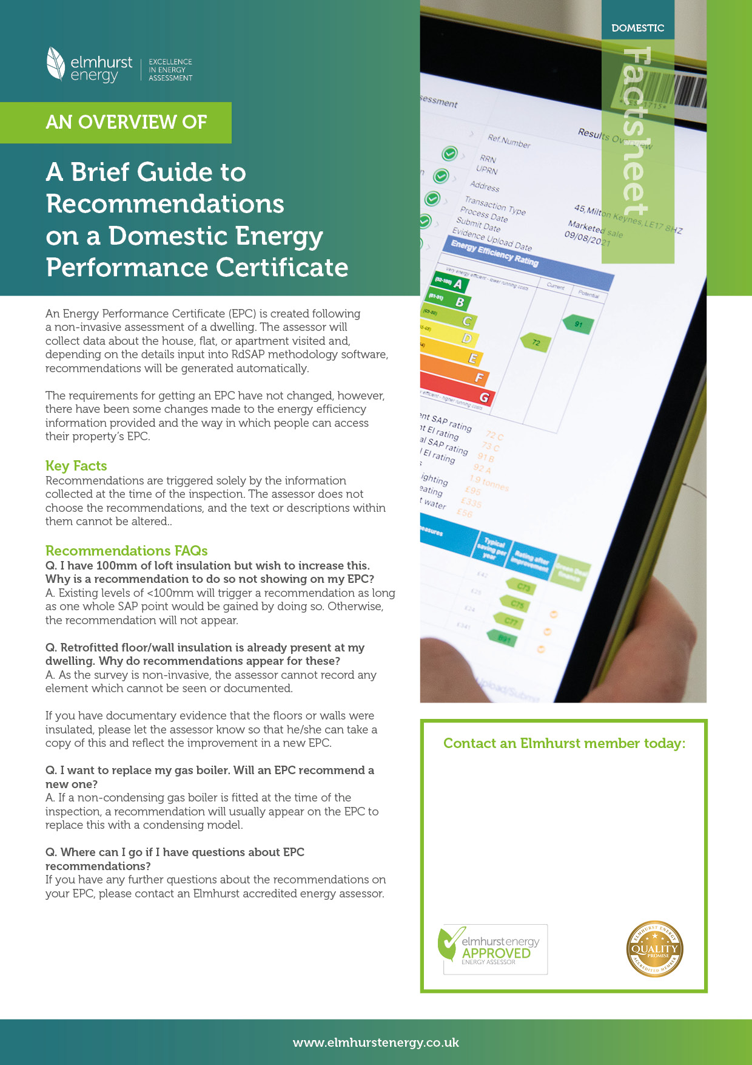
https://www.elmhurstenergy.co.uk/uploads/Appendix_T_Version_9.93.pdf

Astrid Schulz / DEA
Central London EPCs
Contact: +44 (0)7947 155 611

