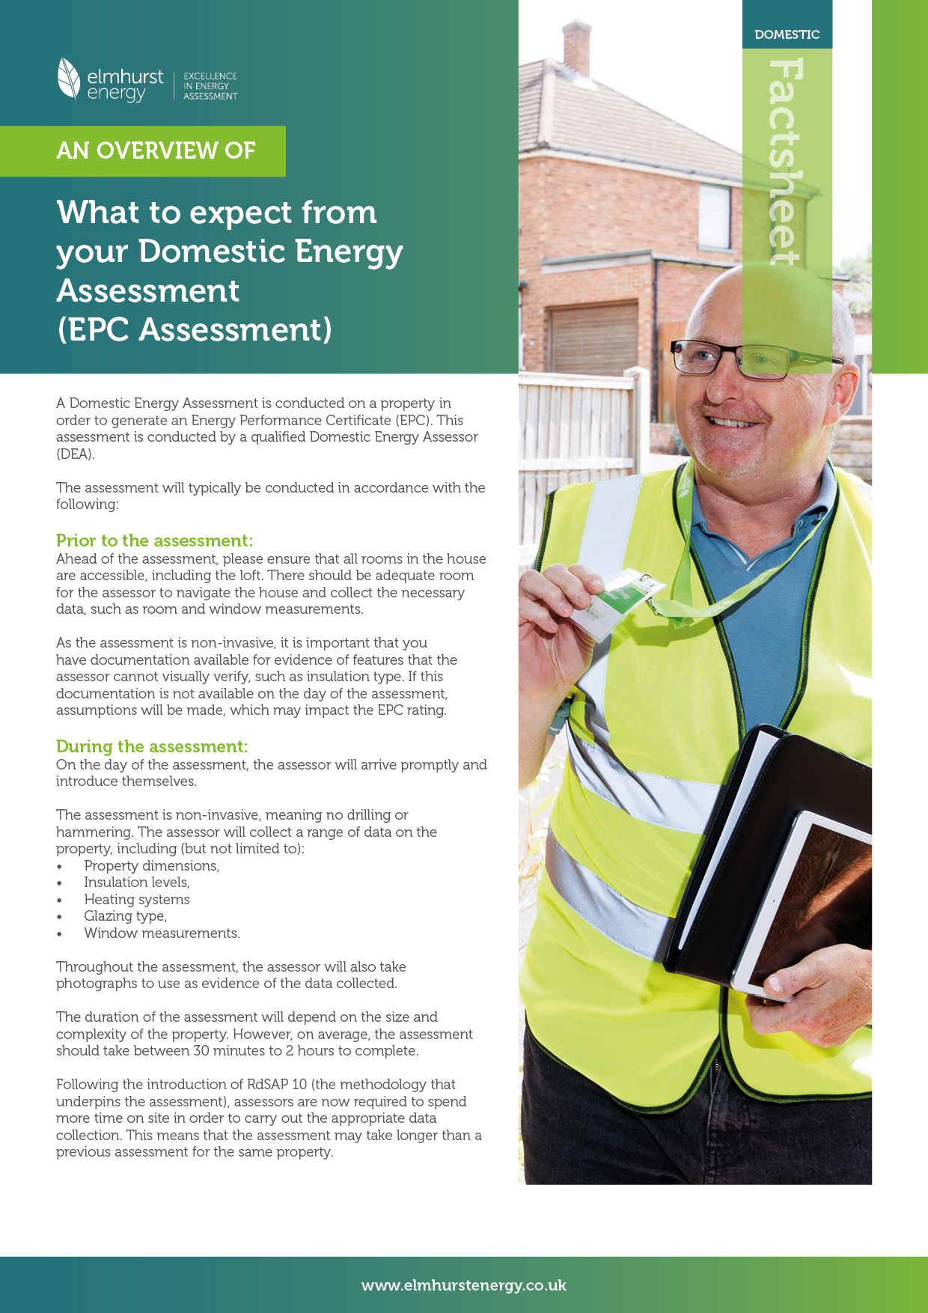
|
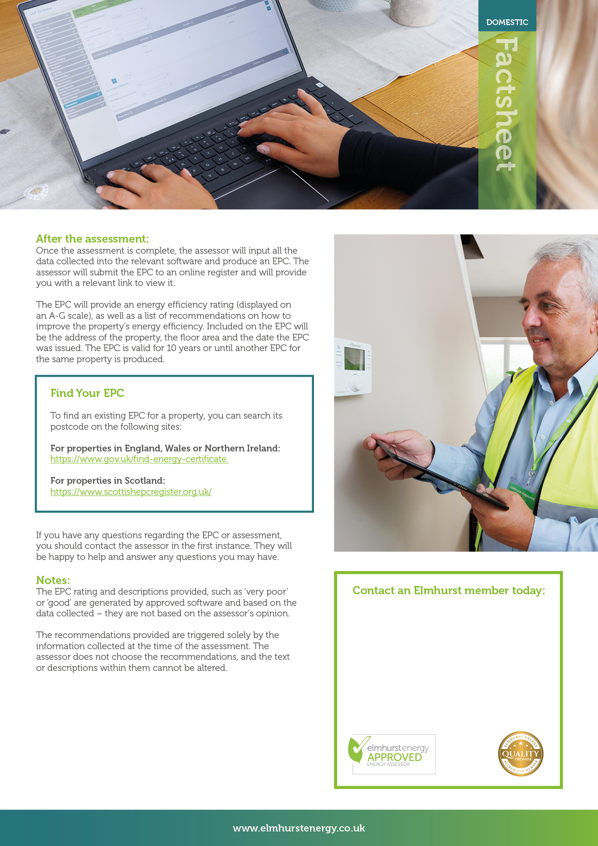

Astrid Schulz / DEA
Central London EPCs
Contact: +44 (0)7947 155 611

